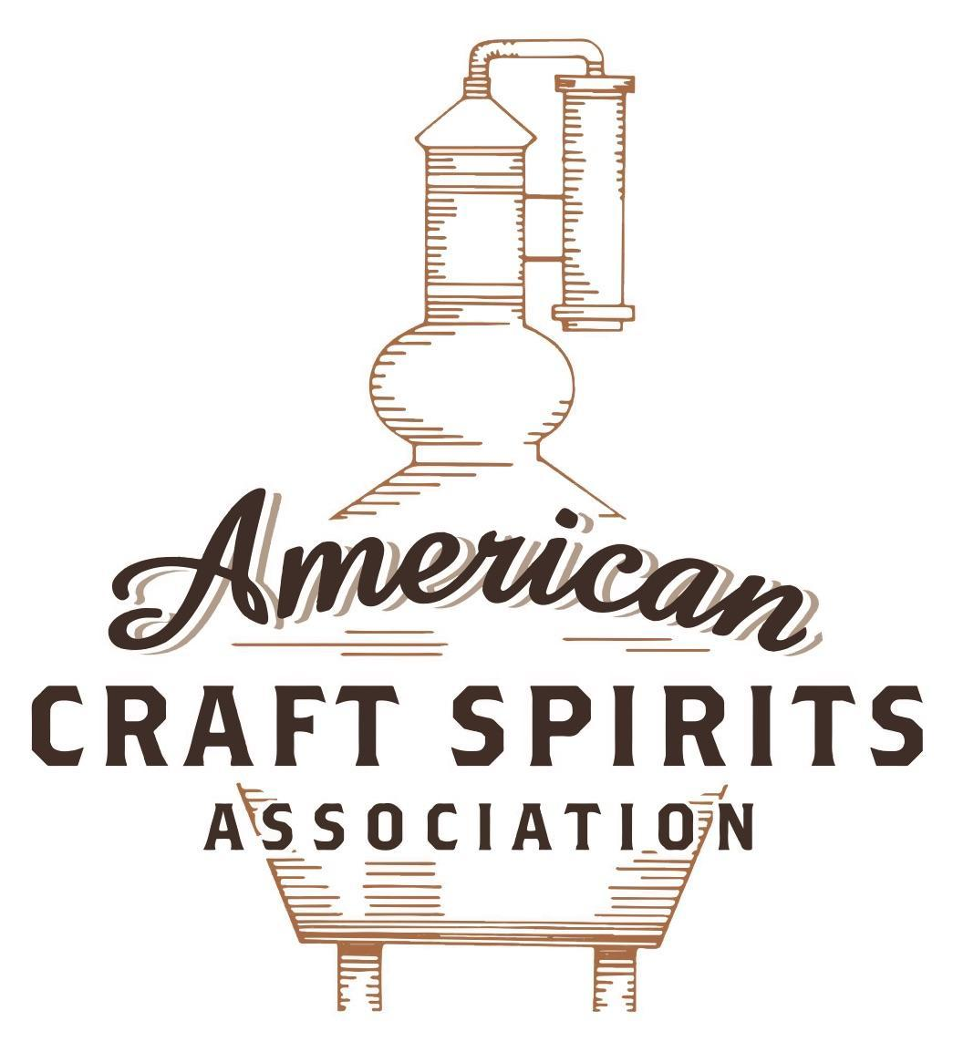
Spirits DtC Shipping Guide

This guide summarizes the direct-to-consumer shipping rules for distilleries in all 50 states and D.C. and also addresses the measures state governments have taken to ease delivery and shipping restrictions during the COVID-19 pandemic.

DtC Quick Guide Comparison

Out-of-State Distilleries  Can Ship Into State? |  |  |  | In-State Distilleries  Can Ship Within State?
State | Yes | No |  | State | Yes | No
AL |  | X |  | AL |  | X
AK | X |  |  | AK | X
AZ | X |  |  | AZ | X
AR |  | X |  | AR |  | X
CA |  | X* |  | CA |  | X*
CO |  | X |  | CO |  | X
CT |  | X* |  | CT |  | X
DE |  | X |  | DE |  | X
DC | X |  |  | DC | X
FL |  | X |  | FL |  | X
GA |  | X |  | GA |  | X
HI |  | X* |  | HI |  | ?*
ID |  | X |  | ID |  | X
IL |  | X* |  | IL |  | X*
IN |  | X |  | IN |  | X
IA |  | X* |  | IA |  | X*
KS |  | X |  | KS |  | X
KY | X |  |  | KY | X
LA |  | X |  | LA |  | X
ME |  | X* |  | ME |  | X*
MD |  | X |  | MD |  | X
MA |  | X |  | MA |  | X
MI |  | X |  | MI |  | X
MN |  | X |  | MN |  | X
MS |  | X |  | MS |  | X
MO |  | X |  | MO |  | X
MT |  | X |  | MT |  | X
NE | X |  |  | NE | X
NV |  | X* |  | NV |  | X
NH | X |  |  | NH |  | X*
NJ |  | X* |  | NJ |  | X*
NM |  | X |  | NM |  | X
NY |  | X* |  | NY |  | X*
NC |  | X |  | NC |  | X
ND | X |  |  | ND | X
OH |  | X |  | OH |  | X
OK |  | X |  | OK |  | X
OR |  | X |  | OR | X
PA |  | X* |  | PA |  | X
RI |  | X* |  | RI |  | X
SC |  | X |  | SC |  | X
SD |  | X |  | SD |  | X
TN |  | X |  | TN |  | X
TX |  | X |  | TX |  | X
UT |  | X |  | UT |  | X
VT |  | X |  | VT |  | X
VA |  | X |  | VA |  | X
WA |  | X* |  | WA | X
WV |  | X* |  | WV |  | X*

WI |  | X |  | WI |  | X
WY |  | X |  | WY |  | X

Notes:
*CA: If passed and signed into law, Senate Bill 620 would allow licensed distilled spirits producers in states other than California and licensed distilled spirits manufacturers or craft distillers in California who obtain distilled spirits direct shipper permits to ship directly to consumers in California
*CT: Consumers with appropriate permit may receive alcohol shipments
*HI: Consumers with appropriate permit may receive alcohol shipments; If passed and signed into law, Senate Bill 65 would allow licensed distilled spirits manufacturers in Hawaii and in states other than Hawaii who obtain direct shipper permits to ship directly to consumers in Hawaii
*IL: If passed and signed into law, Senate Bill 0532 would allow licensed distilled spirits producers in Illinois and in states other than Illinois who obtain distillery shippers’ licenses to ship directly to consumers in Illinois
*IA: If passed and signed into law, House File 639 would allow native distilled spirits manufacturers in Iowa and in states other than Iowa who obtain direct shipper permits to ship directly to consumers in Iowa and to consumers in states other than Iowa
*ME: If passed and signed into law, Legislative Document 1358 would allow distilleries outside of Maine with current manufacturer licenses and distilleries licensed in Maine who obtain spirits direct shipper licenses to ship directly to consumers in Maine
*NJ: (1) If passed and signed into law, Assembly Bill 3167 would allow a craft distillery licensees to ship no more than 9 liters of distilled spirits to a consumer in New Jersey; (2) If passed and signed into law, Senate Bill 3020 would allow craft distillery licensees in New Jersey or in states other than New Jersey to ship no more than 20 liters of distilled spirits to a consumer in New Jersey via common carrier
*NV: Licensed individuals can import one gallon per month of spirits for personal use and the out-of-state supplier must pay excise tax
*NH: If passed and signed into law, Senate Bill 125 would allow licensed liquor manufacturers who obtain direct to consumer shipping permits from the commission to ship directly to consumers in New Hampshire
*NY: Consumer may import up to 90L of liquor per year for personal use without a license; If passed and signed into law, Assembly Bill 3275 would allow licensed liquor manufacturers in states other than New York and licensed distillers and farm distillers in New York to ship no more than thirty-six cases (no more than nine liters per case) of liquor to consumers in New York
*PA: Consumer may place a special liquor order and distiller must ship to a PLCB-operated store
*RI: Distiller can only ship to customer if order was personally placed by customer at distiller's premises
*WA: If passed and signed into law, House Bill 1432 would allow licensed spirits manufacturers in states other than Washington to ship spirits to consumers in Washington
*WV: Distilleries, mini-distilleries, or micro-distilleries licensed in West Virginia or a state other than West Virginia who obtain private direct shipper licenses to ship to a consumer in West Virginia, however the shipments must be made to a retail liquor outlet

NEW HAMPSHIRE
Shipment outbound – No, liquor manufacturers can transport liquor to the state border for transportation and sale outside NH to holders of a US Basic Permit (NH RSA 178:6(VIII)).
Shipment Inbound – Yes, with a direct shipper’s permit (NH RSA 178:27; Admin. R. Liq 1100).
Shipment Intra-state – No, a liquor manufacturer license does not allow NH distilleries to ship directly to customers (NH RSA 178:6; conversation with NH’s Liquor Commission’s Direct Shipping Department).
COVID-19 Measures – As a result of the closures of bars and restaurants to consumers, the NH Liquor Commission issued Industry Circular 2020-04 clarifying that on-premises beverage licensees were restricted to carry-out, delivery, curbside, pick up, and drive through only. Although the industry circular mentioned that all provisions would remain in effect until Monday April 6, 2020, the Executive Order it cites (2020-04) was extended until June 11, 2021. S.B. 66, signed and enacted into law on July 13, 2021, allows an on-premises licensee to purchase a restaurant delivery license from the commission. An on-premises licensee in possession of a restaurant delivery license may transport beverages and wines in their original containers for delivery to consumers for personal consumption if the delivery is accompanied by food prepared by the restaurant delivery licensee.
Industry Circular 2020-04 Link: https://www.nh.gov/liquor/enforcement/industry/documents/industry-circular-delivery-take-out-2020-04.pdf
Twenty-first Extension of State of Emergency Declared in Executive Order 2020-04 Link:
https://www.governor.nh.gov/sites/g/files/ehbemt336/files/documents/2021-10.pdf
S.B. 66 Link:
http://gencourt.state.nh.us/bill_status/billText.aspx?sy=2021&txtFormat=html&v=HA&id=1016
Citation (shipment)
New Hampshire Revised Statutes Annotated
178:6 Liquor Manufacturer License. –
III. Each liquor manufacturer shall have the right to sell at retail at its licensed manufacturing facility no more than the equivalent of 3,000 9-liter cases for off-premises consumption any of its liquor. Each retail sale shall be limited to one 9-liter case or less per sale. No liquor manufacturer shall sell more than 12 9-liter cases of liquor to any one customer in any calendar year.
VIII. Each liquor manufacturer shall have the right to transport the liquor it manufactures, blends, or bottles in bottles or other closed containers to the state border for transportation and sale outside the state to holders of a United States basic permit issued under the Federal Alcohol Administration Act.
Link: http://www.gencourt.state.nh.us/rsa/html/xiii/178/178-6.htm
178:27 Direct Shippers. –
I. (a) Notwithstanding any other provision of law to the contrary, any person currently licensed in its state of domicile as a wine manufacturer, beverage manufacturer, importer, wholesaler, or retailer shall apply for a direct shipper permit from the commission.
(b) Applicants for a direct shipper permit shall be exempt from the provision of RSA 178:1, I requiring registration with the secretary of state, if the applicant is duly organized and registered to do business under the laws of the state in which the applicant is domiciled.
II. A direct shipper may ship directly to New Hampshire consumers over 21 years of age or licensees in packages clearly marked "Alcoholic Beverages, adult signature (over 21 years of age) required.'' All shipments from direct shippers into the state shall be made by a licensed carrier and such carriers are required to obtain an adult signature. Direct shippers or carriers shall not ship into areas of the state where alcohol beverages may not be lawfully sold. Liquor and wine that has been registered for sale to the commission with the commission during the previous 2 months may be direct shipped only if the shipper offers to sell a matching amount to the commission at wholesale. Shipments of any other products shall be considered unlicensed shipments under the provisions of RSA 178:1, I.
III. Except with written permission of the commission, no direct shipper shall ship more than 60 individual containers of not more than one liter each of liquor and not more than 12 - 9 liter cases or equivalent of wine to any one consumer in New Hampshire in any calendar year. The commission shall only grant permission for additional shipments if the additional shipments are of products not otherwise available in New Hampshire. Furthermore, in the event any direct shipper wishes to ship more than a total of 600 liters of any particular liquor or wine directly to any combination of licensees and/or consumers in New Hampshire, the shipper shall offer to sell a matching amount to the commission or beer distributor at the lower of the wholesale price or the lowest price delivered into New Hampshire. A licensee may purchase from a direct shipper pursuant to RSA 179:32, III.
IV. No direct shipper shall ship more than 27 gallons of beer or beverage in individual containers of not more than one liter to any consumer's address in New Hampshire in any calendar year. No direct shipper shall ship beer or beverage to a New Hampshire licensee.
V. (a) Direct shippers shall file reports for each shipment with the liquor commission, and shall pay a fee of 8 percent of the retail price for shipments of liquor, wine, beer, or beverage to the commission. Such reports shall be filed once per month for any month in which a shipment was made in a manner and form required by the commission and include the following information:
(1) The total amount of alcoholic beverages shipped into or within the state for the preceding month.
(2) The names and addresses of the purchasers to whom the alcoholic beverages were shipped.
(3) The date of purchase, if appropriate, the name of the common carrier used to make each delivery, and the quantity and retail value of each shipment.
(b) The commission may assess a $250 penalty for failure to report to the commission in a timely manner.
(c) Direct shippers shall maintain records for at least 3 years which will permit the commission to ascertain the truthfulness of the information filed and permit the commission to perform an audit of the direct shippers' filings upon reasonable request. Wholesale shipments of any liquor or wine shall be permitted only in accordance with RSA 175:6.
VI. The liquor commission shall adopt rules, pursuant to RSA 541-A, relative to:
(a) The application procedures and form for the direct shipper permit authorized under paragraph I.
(b) The signature form or other identification procedures to be used by direct shippers to ensure that consumers to which liquor and beverage are being shipped are over 21 years of age.
(c) Filings of direct shippers under paragraph V.
VII. Notwithstanding the provisions of RSA 179:58, any person holding a direct shippers permit under this section who ships liquor, wine, or beer to a person under 21 years of age, shall be guilty of a class B felony and shall have such permit permanently revoked.
VIII. Upon notification by authorities in another state which imposes a reciprocal enforcement policy, a New Hampshire licensee proved to be making illegal direct shipments to consumers and licensees in said state shall be subject to action by the liquor commission. Such actions may include fines and suspension and revocation of New Hampshire liquor licenses.
Link:
http://www.gencourt.state.nh.us/rsa/html/xiii/178/178-27.htm

CHAPTER Liq 1100 RULES RELATING TO DIRECT SHIPMENT Link:
https://www.nh.gov/liquor/enforcement/licensing/documents/1100ds-rules.pdf

The American Craft Spirits Association (ACSA) is working diligently to give our members and industry partners relevant, current updates on statutes and regulations impacting production, sale and distribution of spirits. With the declaration of the novel coronavirus (COVID-19) in early 2020, many states have issued temporary policy changes or longer-term modernization of alcohol beverage laws. State statutes, regulations created by the state alcohol regulatory authority, as well as any other relevant guidance provided by such authorities (such as advisories, opinions, bulletins, etc.) were reviewed in creation of this document. No city or county ordinances were reviewed. Distillers should be aware that even in states where direct shipping is permissible, always remember to avoid shipping to dry counties. Please consult with your state guild or alcohol beverage authority for the most up-to-date information. This content is intended for educational and informational purposes only. ACSA's pro bono law firm of Malkin Law P.A. provided the core content found in this comprehensive overview of the spirits distribution after COVID-19. It was completed in August 2021 and will be updated regularly. If you have updates you would like to provide, please send to legislation@americancraftspirits.org or directly to the law firm at: ryan@malkin.law / malkin.law. Thank you.
S.B. 125, passed on July 1, 2021, allows a business licensed as a beverage manufacturer, nano brewery, brew pub, wine manufacturer, liquor manufacturer, or beverage distributor to apply for a direct to consumer shipping permit from the commission, which authorizes the sale and delivery of alcohol beverages to a consumer who is at least 21 years of age. A liquor manufacturer may not ship more than 60 individual containers of not more than one liter each of liquor to any consumer in New Hampshire in a year. All shipments must be made by a licensed carrier as defined in RSA 178:14. Link: http://gencourt.state.nh.us/bill_status/billText.aspx?sy=2021&txtFormat=html&v=HA&id=891

